Procedure: General Safety and Health for Hazardous Materials Response

Preamble:

These procedures are intended for the use of HazMat Teams and are not intended for the use by normal engine company personnel.

Purpose:

The purpose of this Procedure is to outline the MINIMUM safety and health policies and procedures to be utilized at incidents involving hazardous materials. These incidents are defined as those which involve materials or products which, by their chemical and physical characteristics, present a physical, health, biological or radiological hazard to operating personnel. For the purpose of this policy, flammable or combustible liquids and flammable gases are specifically covered by this policy as was the intent of the Federal Occupational Safety and Health Administration during the development of 29 CFR 1910.120 “Hazardous Waste Operations and Emergency Response”, herein referred to as “HAZWOPER”.

Background:

This Procedure is intended to comply with Federal EPA 40 CFR 311, 29 CFR 1910.120 “HAZWOPER”, and as recommended by National Fire Protection Association in their consensus standard 471, “Recommended Practice for Responding to Hazardous Materials Incidents”, 472 “Standard for Professional Competence of Responders to Hazardous Materials Incidents”, & 473 “Standard for Competencies for EMS Personnel Responding to Hazardous Materials Emergencies”.

Policy:

Effective immediately, the following activities shall be instituted at all incidents involving hazardous materials. These activities are designed to comply with applicable federal safety regulations, and to the extent possible, ensure the safety and health of Department personnel during such operations.

General Requirements and Initial Response Operations

Control Zones

Control Zones shall be established in accordance with the Emergency Response Guidebook (ERG) for the material involved or as a minimum 150’ in all directions. In those instances where the material cannot be identified, follow recommendations of the ERG.

Initial Safety Plan

The Incident Commander (IC) shall advise all emergency response personnel of the appropriate ERG Guide Page number to utilize. This Guide Page shall constitute the “Initial Site Safety Plan” for the initial stages of the incident and shall be reviewed by all personnel prior to operating at the incident.

Safety Officer

During the beginning stages of a hazardous materials emergency, and prior to the arrival of additional resources, the Incident Commander shall further serve as the Site Safety Officer. In this respect, the Incident Commander shall ensure implementation of the Initial Site Safety Plan.
Should the Incident Commander or Safety Officer observe conditions which place response personnel in immediate danger, the Incident Commander or Safety Officer shall immediately suspend or terminate the operations until the safety hazards are corrected.

Obtain Additional Assistance

The Incident Commander shall, upon knowledge that a hazardous material is involved, request the immediate dispatch of an appropriately staffed hazardous materials response unit (as designated in the Florida Association for HazMat Responders Typing Policy) and other resources deemed necessary for the safe and effective management of the incident. This may include a request for response by additional HazMat Teams, mutual aid or State District Response Team/s.

Personnel Training

Only those personnel who have been trained to the level of First Responder Operational as defined by NFPA consensus Standard 472-2-3, Professional Competence of Responders to Hazardous Materials Incidents, shall be permitted to operate in a capacity which would subject that person to a potential exposure to a hazardous material, and then, such operations shall be defensive in nature while avoiding direct contact with the product. Exceptions would be made for those incidental spills in accordance with OSHA Initiatives and department policies.

Hazard/Risk Assessment

The Incident Commander shall, by all reasonable means available, attempt to identify the material(s) involved and reference the material(s) in the ERG.

At no time shall personnel be committed to a hazardous atmosphere (of any nature) without appropriate personal protective equipment and training. All personnel shall work in the “buddy system” and, when operating in potentially IDLH environments, a back-up team (RIT) shall be established.

The minimum acceptable personnel protection for initial actions at a hazardous materials incident is that which is recommended by the ERG. Personnel meeting the training requirements of the First Responder Operational Level, as outlined above, when properly protected, may engage in the following defensive control activities:

1. Isolation of the hazardous area.
2. Rescue and evacuation of injured and endangered persons.
3. Defensive product control measures such as damming, diking, and retention of products.
4. Fire control operations without chemical exposure.
5. Support operations.
6. Remote shut off activations
7. Other offensive actions as allowed for by other OSHA Interpretations and by organizational policies as training and protection allow.
8. Decontamination Activities when properly trained and protected.

Persons trained to the Operational Level may engage in some limited offensive activities provided the following three conditions are met:

  - They are properly trained to perform the task.
  - They are properly protected and equipped.
  - They are aware of the risk.

Hazardous Materials Group

Command Structure

As an incident progresses, so shall the incident command structure. The designated on-scene individual shall assume Command of the incident and the command structure shall be developed in accordance with the Florida FOG Incident Command Procedures.

Within the Incident Command System a HazMat Group/Branch/Branch shall be established in accordance with Florida FOG Hazardous Materials Chapter. The HazMat Group/Branch/Branch shall assume authority of all operations within the Hot and Warm Zones. The HazMat Group/Branch/Branch Supervisor shall be designated in accordance with agency policy.

Safety Officer

In addition to any on-scene Safety Officer a knowledgeable HazMat Safety Officer shall be designated. This Safety Officer shall observe all operations within the Hot and Warm Zones and shall have the full authority to suspend, modify or terminate any operations if the immediate safety and health of personnel are endangered. Such actions shall require the immediate notification of the HazMat Group/Branch/Branch Supervisor and if necessary the Incident Commander.

Hazard Risk Assessment

The Hazardous Materials Group shall perform a site specific Hazard/Risk Assessment in accordance with available resources and information. Product, container, and environment shall be considered.

Site Safety Plan

A written Site Specific Safety Plan shall be developed and enforced by the Haz-Mat Group Safety Officer.
It shall be the responsibility of the Haz-Mat Safety Officer to ensure that all personnel have reviewed the plan prior to entry into the hazardous atmosphere. This plan shall include the following:

1. Site description and physical hazards.
2. Materials involved, routes of exposure and signs and symptoms of over-exposure.
3. Required personal protective equipment for the specific task to be performed.
4. Required medical and environmental monitoring.
5. Radio communication frequency designation for intervention team and support operations.
6. Entry objectives.
7. Emergency procedures.

Control Zones

Control zones shall be established based upon information obtained through the hazard/risk assessment and continuously reassessed and adjusted as necessary.

Communication Procedures

Communications with all entry personnel shall be established by either
- Direct line of sight with the Group Supervisor
- Dedicated radio communications channel
All other on-scene communications will be conducted in accordance with local policy and in plain text.

In addition, the standardized hand signals are provided at the end of this chapter shall be used.

Rapid Intervention (Back-up) Team:

A team of sufficient size based upon the size and complexity of the incident and the risk assessment conducted by the HazMat Group/Branch Supervisor shall be designated as a Rapid Intervention Team (RIT). This team shall be protected to at least the same level of protection as the highest level of personal protective equipment operating onsite and readied with appropriate rescue equipment. If multiple site operations are being conducted, then the use of multiple RIT teams should be considered.

Emergency Medical Support:

An Advanced Life Support (ALS) unit and transport capability shall be designated to the HazMat Group/Branch to manage any medical needs of responders including emergencies. This resource shall be staged within the Cold (support) zone of operations.

Entry Objectives

Entry objectives shall be identified by the Incident Commander and the HazMat Group/Branch Supervisor and included in the Incident Action Plan. The HazMat Group/Branch Supervisor shall ensure that all entry personnel and RIT members are aware of any operational objectives prior to entry into the Hot (exclusion) zone.

Emergency Evacuation/Retreat

The emergency evacuation signal shall be established in accordance with the Florida Incident Field Operations Guide (FOG) Incident Safety and Accountability Guidelines.

The emergency evacuation signal shall be ordered in any cases of injury to entry personnel while operating in the Hot Zone or in any situations where an unexpected threat to the safety or health of operating personnel is deemed to exist. Upon hearing the emergency evacuation signal, the following shall occur:
1. Entry teams shall immediately exit the Hot Zone and proceed directly to the decontamination area.
2. HazMat Medical treatment personnel shall report to the clean end of the decon corridor.
3. Conduct a Personnel Accountability Report (PAR)
4. Radio silence shall be instituted and frequencies cleared to allow command and emergency communications.
The radio silence shall remain in effect until lifted by the Incident Commander. The decision to lift the radio silence shall be based upon the recommendations of the HazMat Group/Branch Safety Officer.

Site Specific Safety Plan

The attached Site Specific Safety Plan shall be instituted by the Haz-Mat Safety Officer for all incidents involving offensive control procedures or Hot Zone entries utilizing specialized chemical protective clothing.

The contents of this plan shall be made available to all personnel operating at the scene (Department or otherwise) prior to initiating the site entry.
The Safety Plan shall be periodically reviewed and revised by the Safety Officer as necessary.
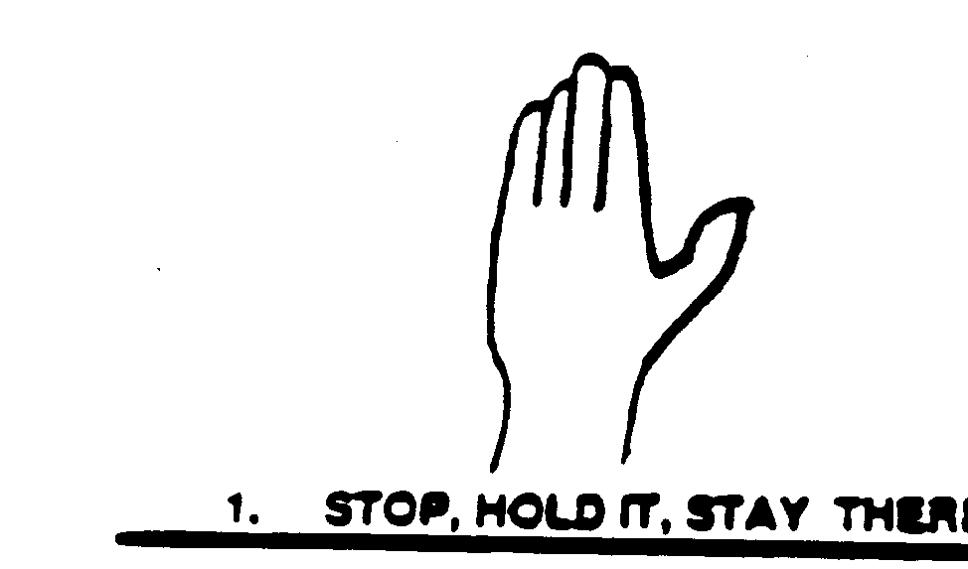
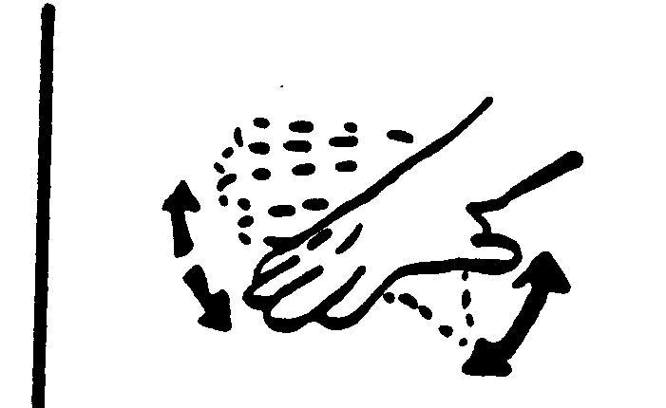
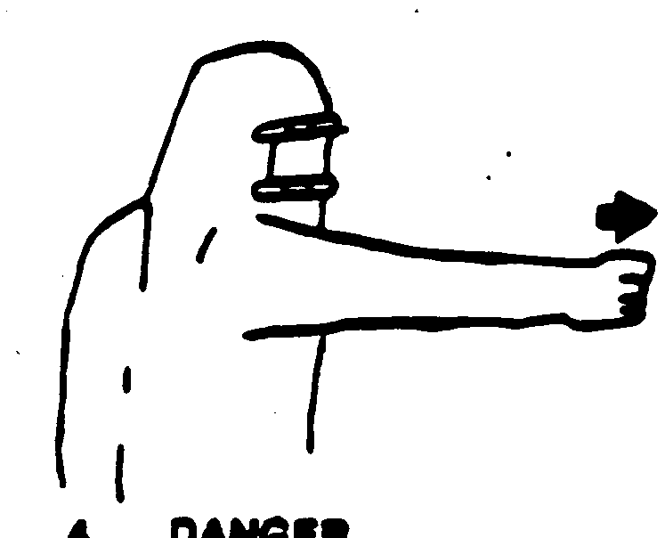


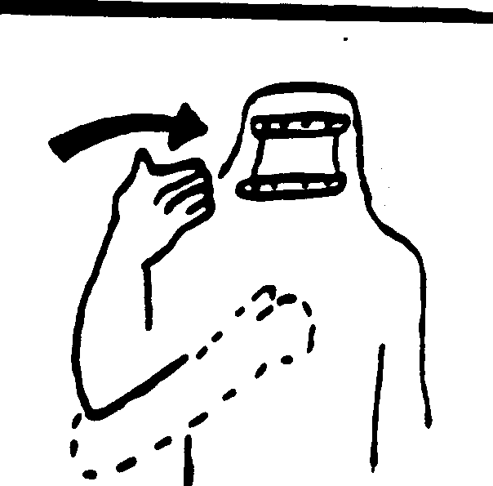
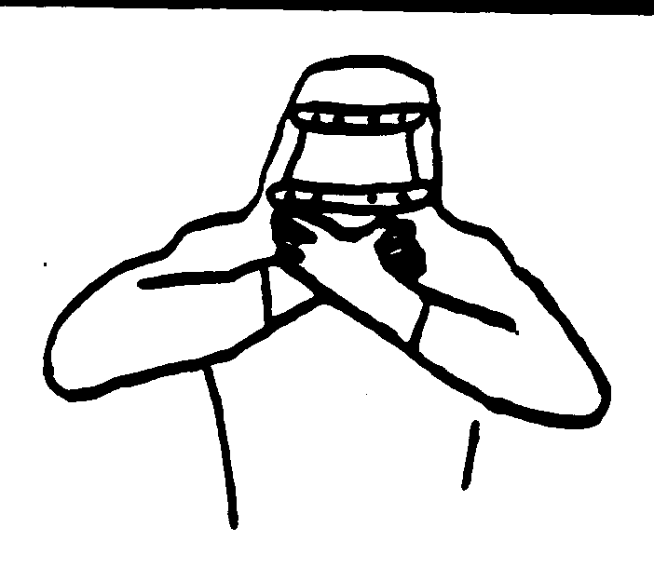
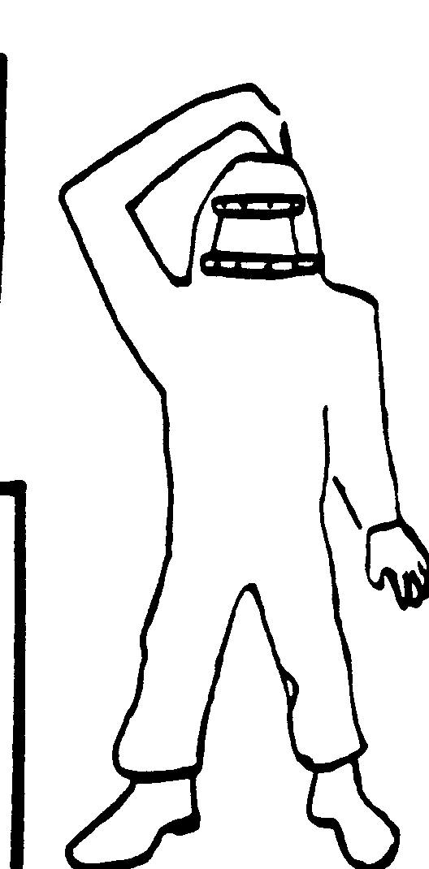

STOP, HOLD IT, STAY THERE
SOMETHING IS WRONG
DANGER
GO DOWN, GETTING DOWN
GO UP
COME HERE
OUT OF AIR
OK
WHICH WAY?
Standardized Hand Signals

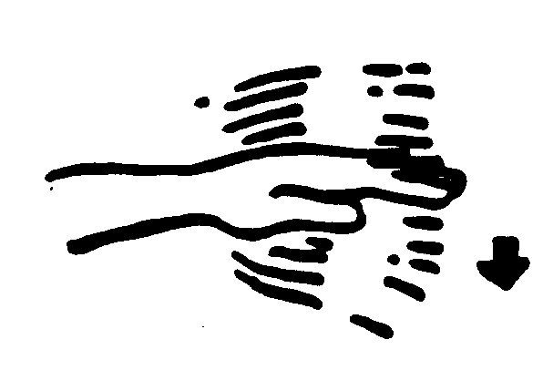

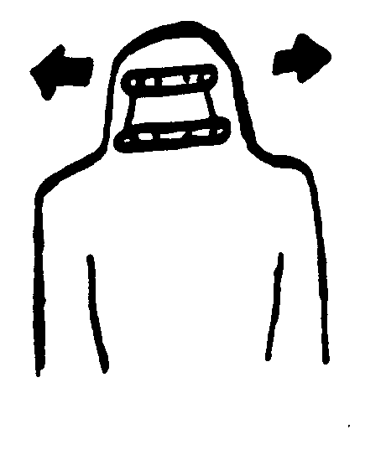


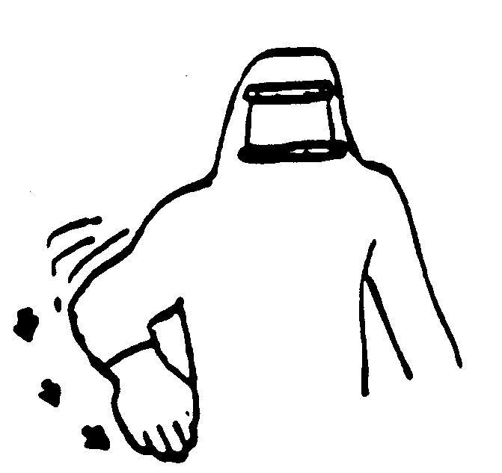

TAKE IT EASY,
SLOW DOWN
ME, OR WATCH ME
YES
NO
YOU LEAD,
I’LL FOLLOW
HANDS RAISED OVER HEAD N CIRCULAR MOTION
I NEED HELP,
I’M IN TROUBLE.
MAYDAY
UNDER, OVER, AROUND

